TOP CLASS LESSON NOTES FOR WRITING

**Term one -2020**

WEEK 1

Orientation

* welcoming the learners
* Taking the learners around the school
* Showing the learners important places e.g. like toilets, offices, class and dormitories
* Showing the learners important people in the school i.e. teachers, caregiver, headteacher and bursar

WEEK TWO

PD1

CONTENT

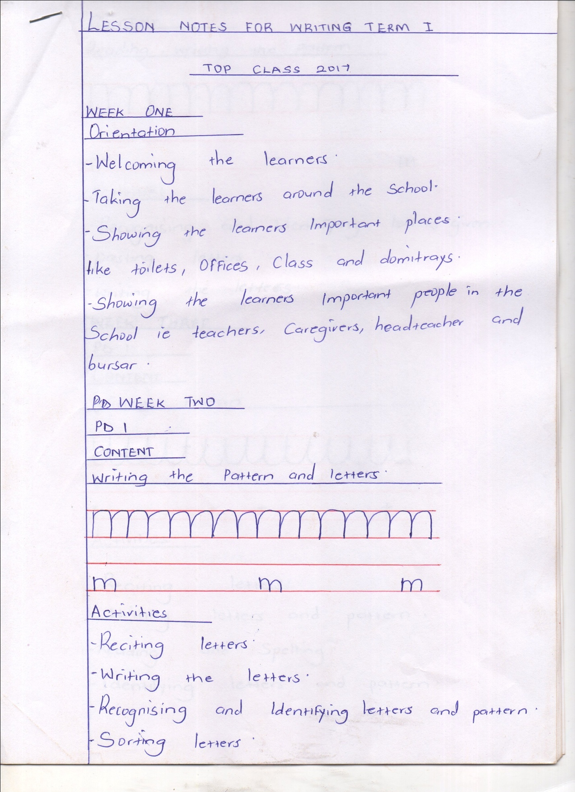Writing the pattern and letters

Activities

* Reciting letters
* Writing the letters
* Recognizing and identifying letters and pattern
* Sorting letters

PD 2 – 3

CONTENT

Reading, writing the pattern

WEEK THREE

PD 1

CONTENT

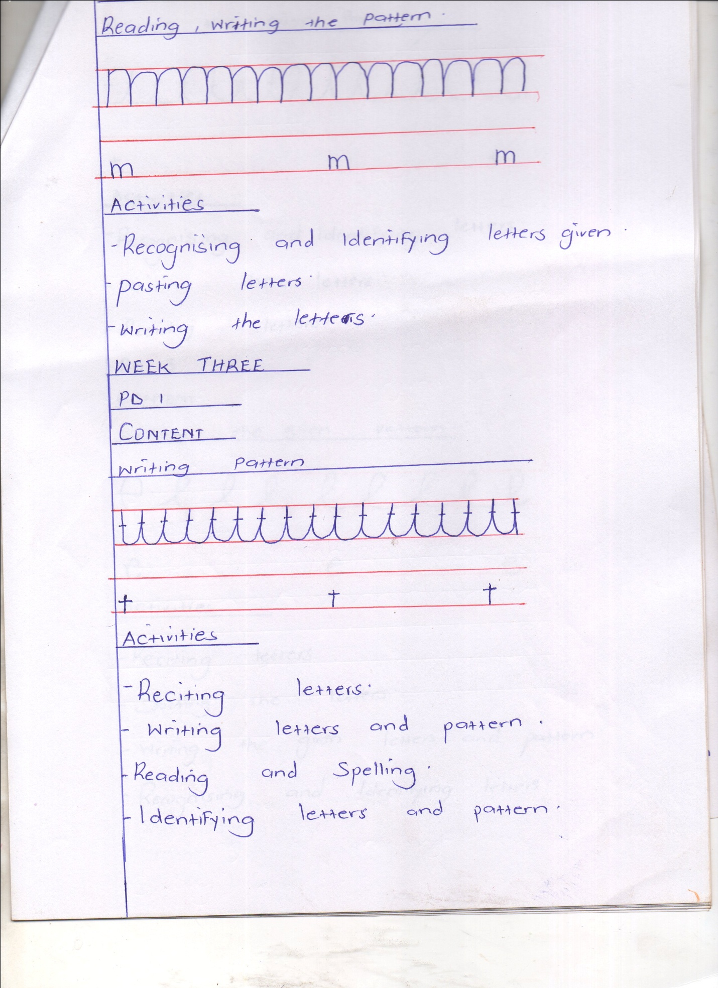Writing pattern

Activities

* Reciting letters
* Writing letters and pattern
* Reading and spelling
* Identifying letter and pattern

PD 2

CONTENT

Writing the given pattern

Activities

* Recognizing and identifying letter
* Writing the letters
* Reciting letter

PD 3

CONTENT

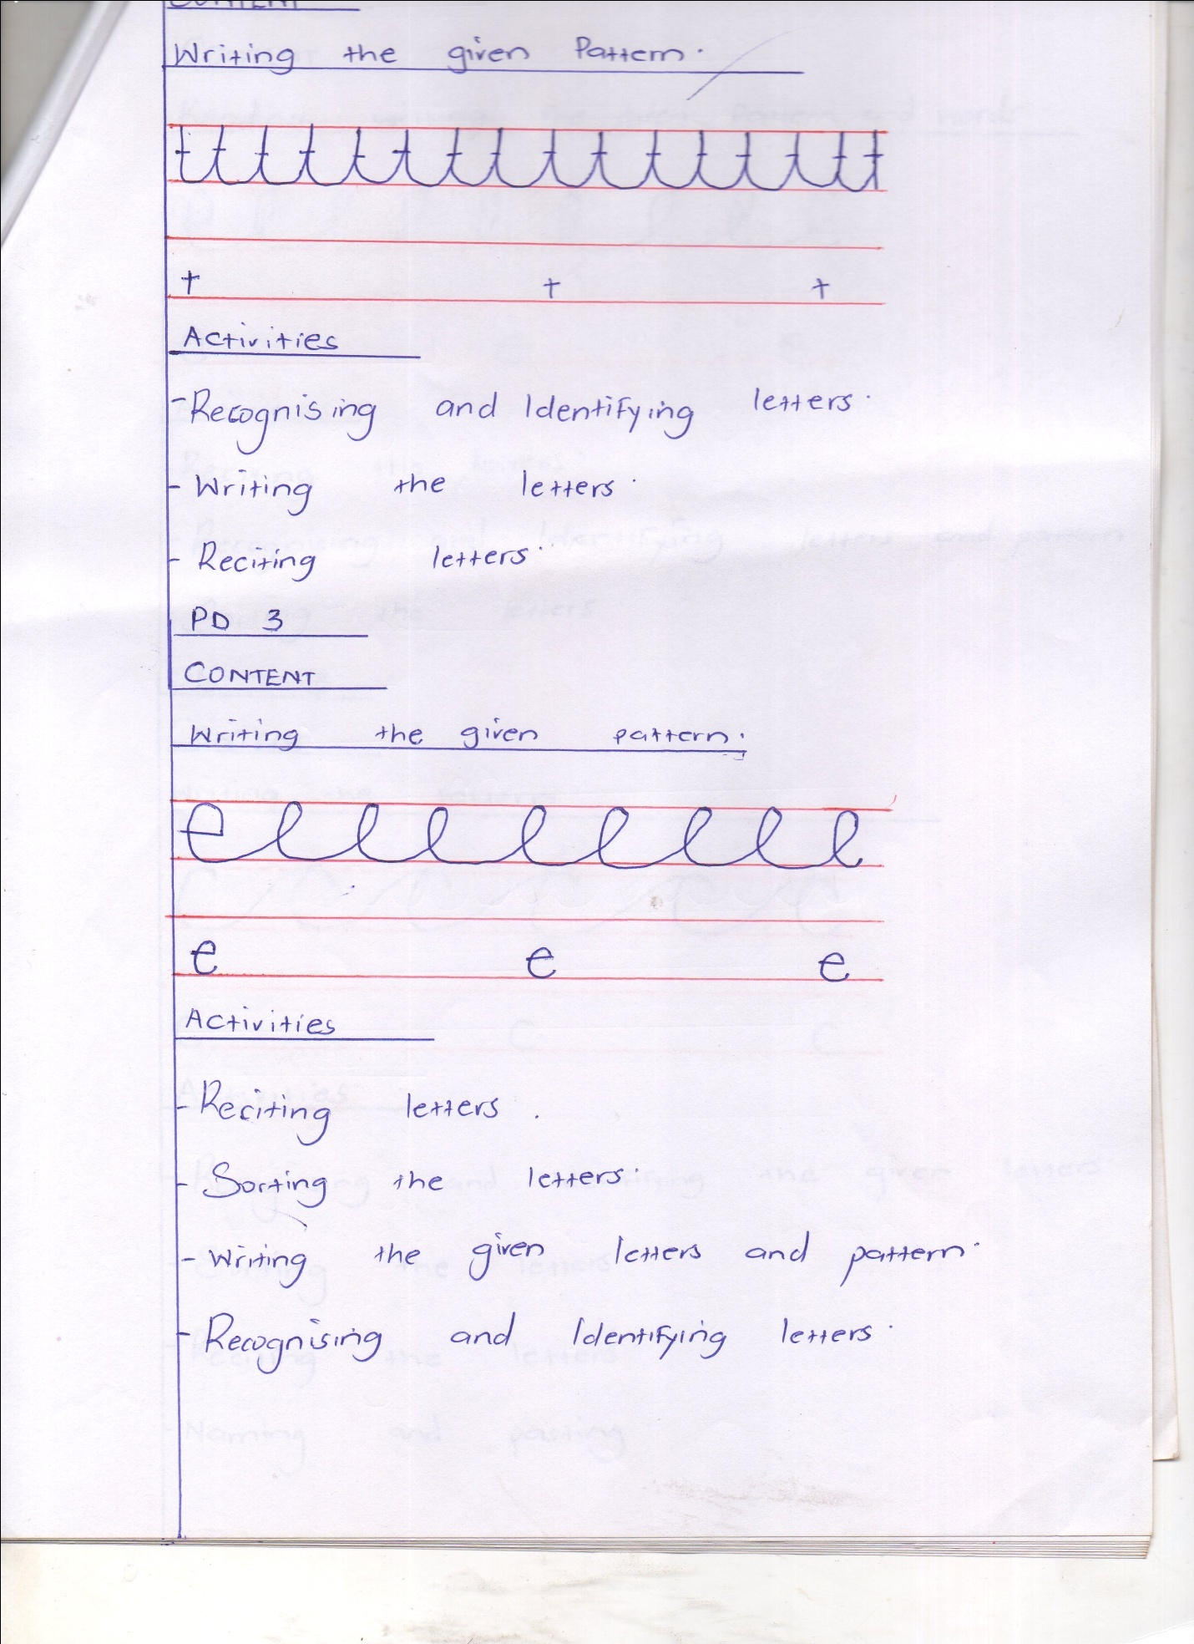Writing the given patter

Activities

* Reciting letters
* Sorting the letters
* Writing the given letters and pattern
* Recognizing and identifying letters

WEEK FOUR

PD 1

Reading, writing the given pattern and words

**Activities**

* Reciting the letters
* Recognizing and identifying letters and pattern
* Sorting the letters

PD 2- 3

CONTENT

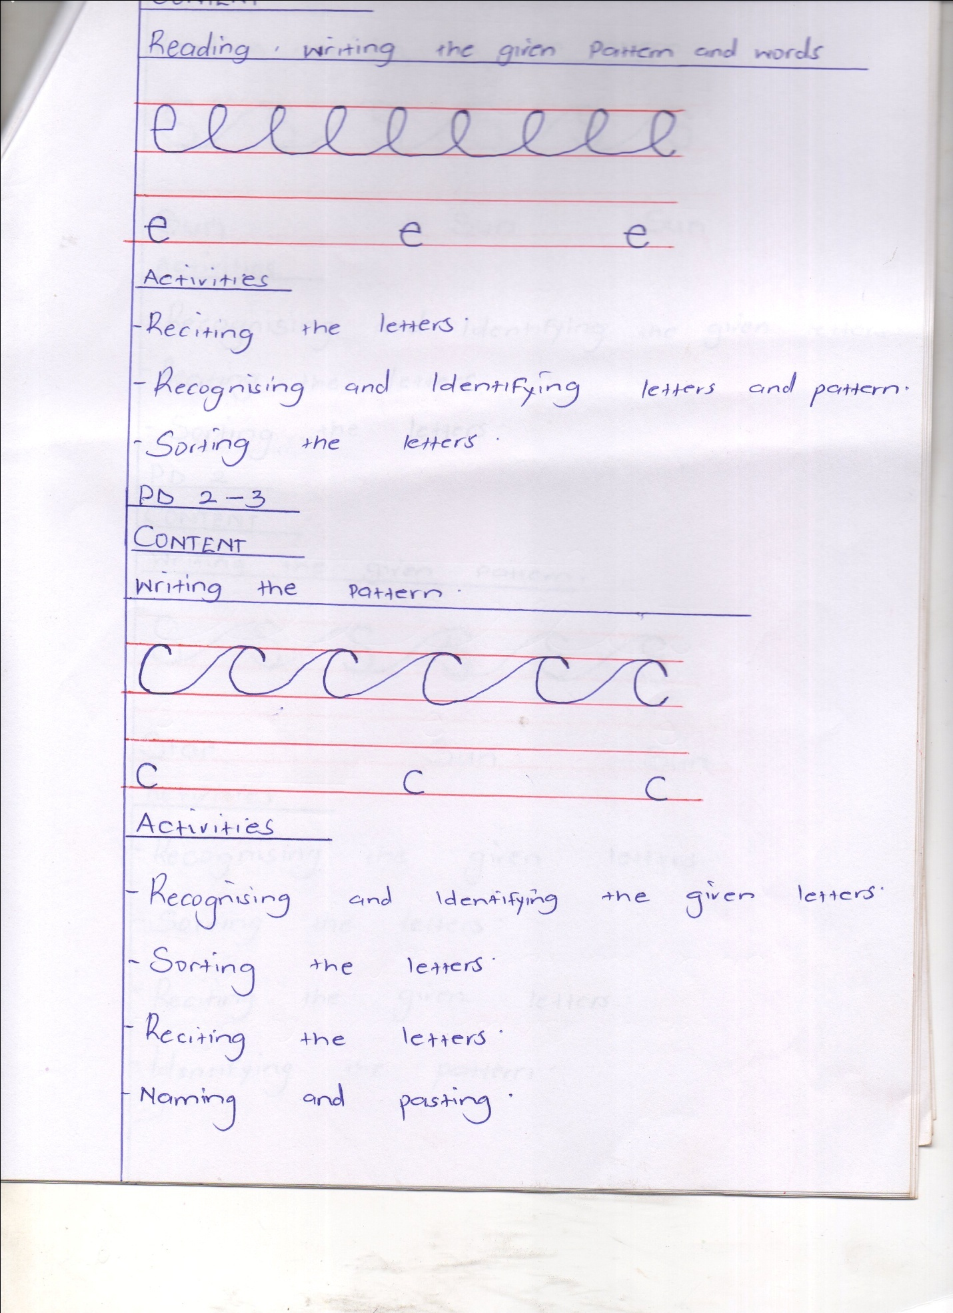Writing the pattern

Activities

* Recognizing and identifying the given letters
* Sorting the letters
* Reciting the letters
* Naming and pasting

WEEK FIVE

CONTENT

PD 1

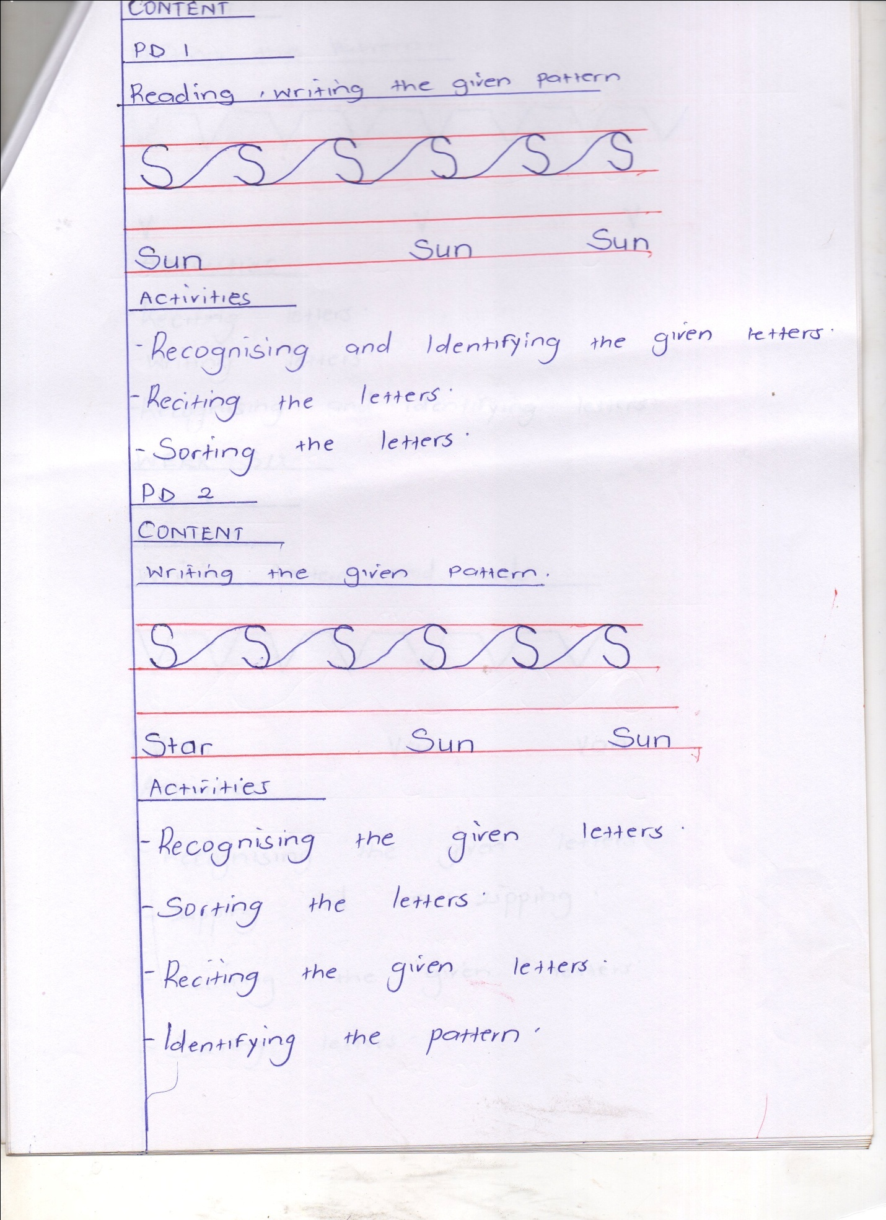Reading, writing the given pattern

Activities

* Recognizing and identifying the given letters
* Reciting the letters
* Sorting the letters

PD 2

CONTENT

Writing the given pattern

Activities

* Recognizing the given letters
* Sorting the letters
* Reciting the given letters
* Identifying the pattern

PD 3

CONTENT

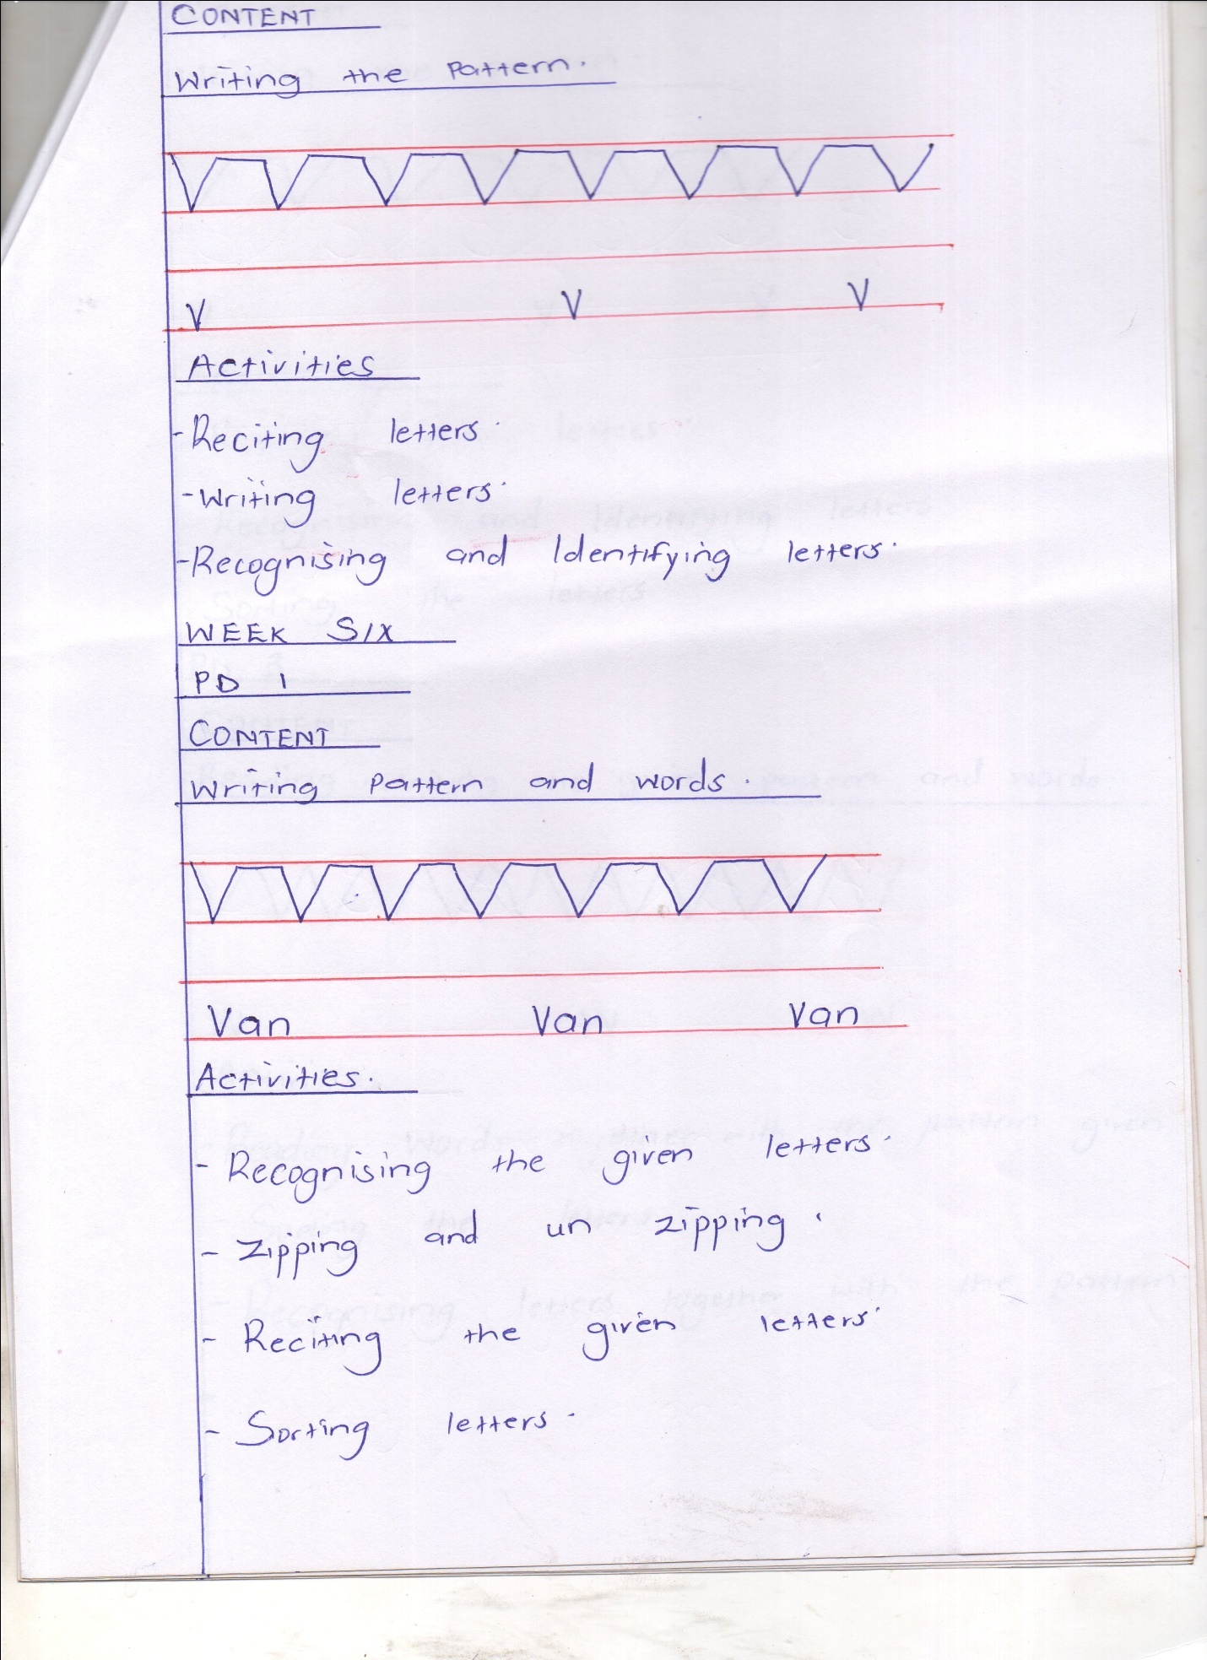Writing the pattern

Activities

* Reciting letters
* Writing letters
* Recognizing and identifying letters

WEEK SIX

CONTENT

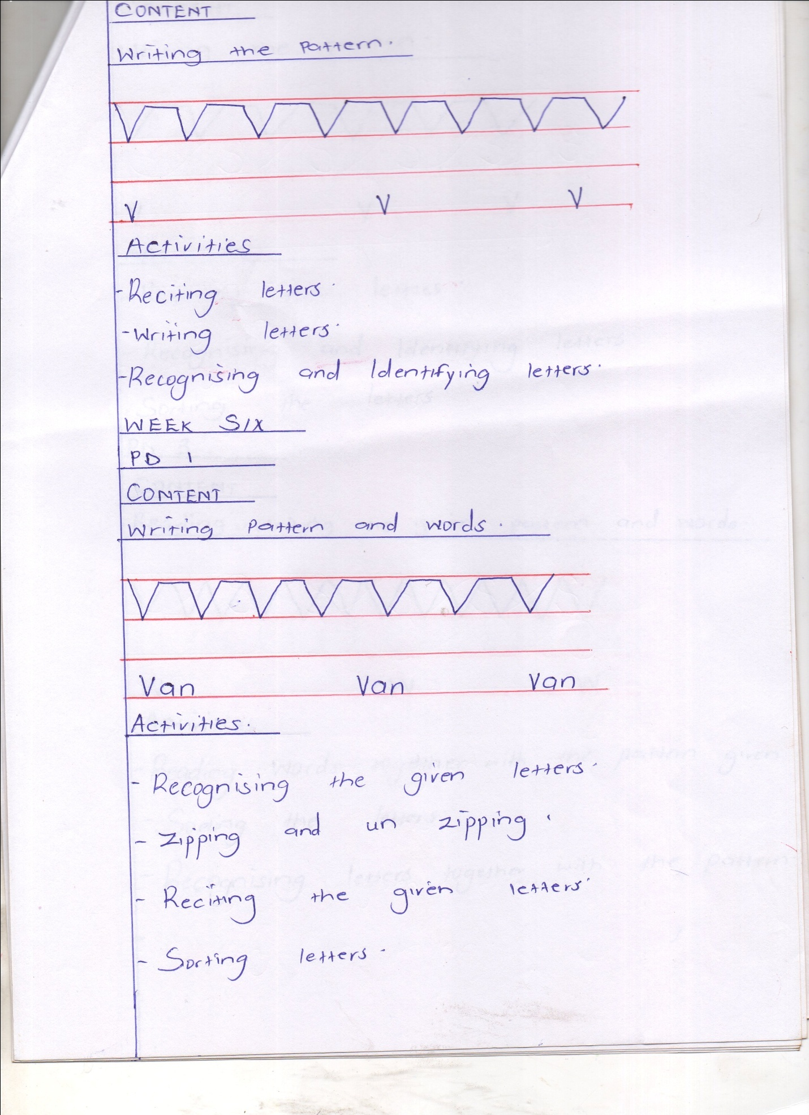Writing pattern and words

Activities

* Recognizing the given letters
* Zipping and sun zipping
* Reciting g the given letters
* Sorting letters

PD 2

CONTENT

Writing the pattern

Activities

* Reciting the letters
* Recognizing and identifying letters
* Sorting the letters

PD 3

CONTENT

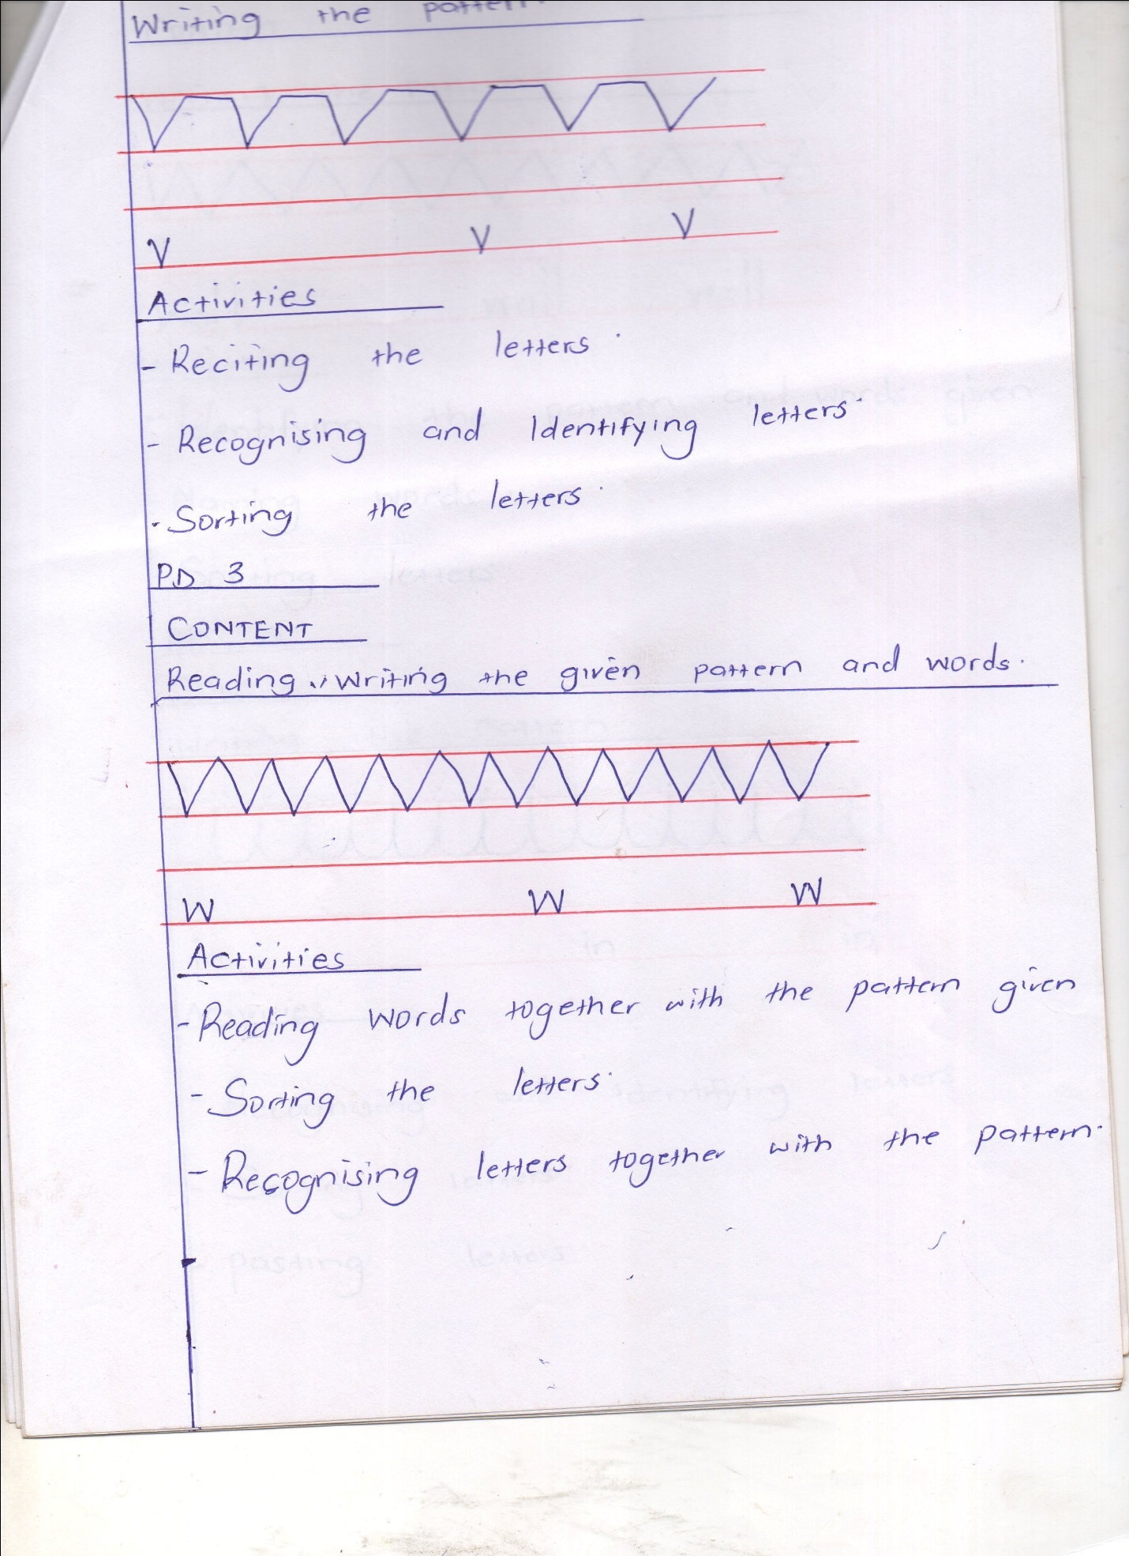Reading writing the given pattern and words

Activities

* Reading words together with the pattern give
* Sorting the letters
* Recognizing letters together with the pattern

WEEK SEVEN

PD 1

CONTENT

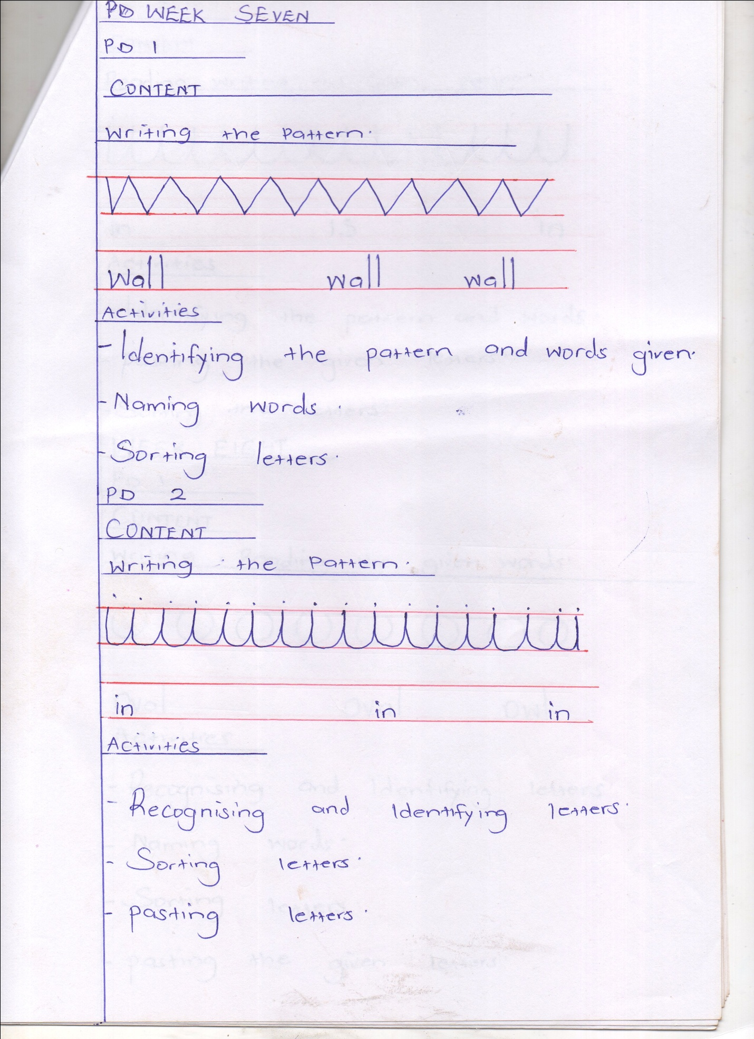Writing the pattern

Activities

* Identifying the pattern and words given
* Naming words
* Sorting letter

PD 2

CONTENT

Writing the pattern

* Recognizing and identifying letters
* Sorting letters
* Pasting letters

PD 3

CONTENT

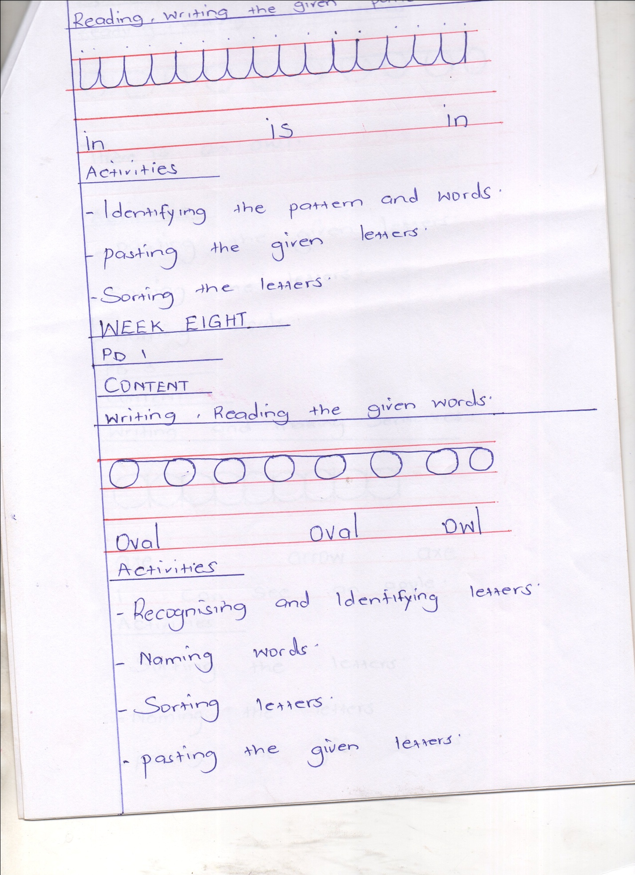Reading, writing, the given pattern

Activities

* Identifying the pattern and words
* Pasting the given letters
* Sorting the letters

WEEK EIGHT

PD 1

CONTENT

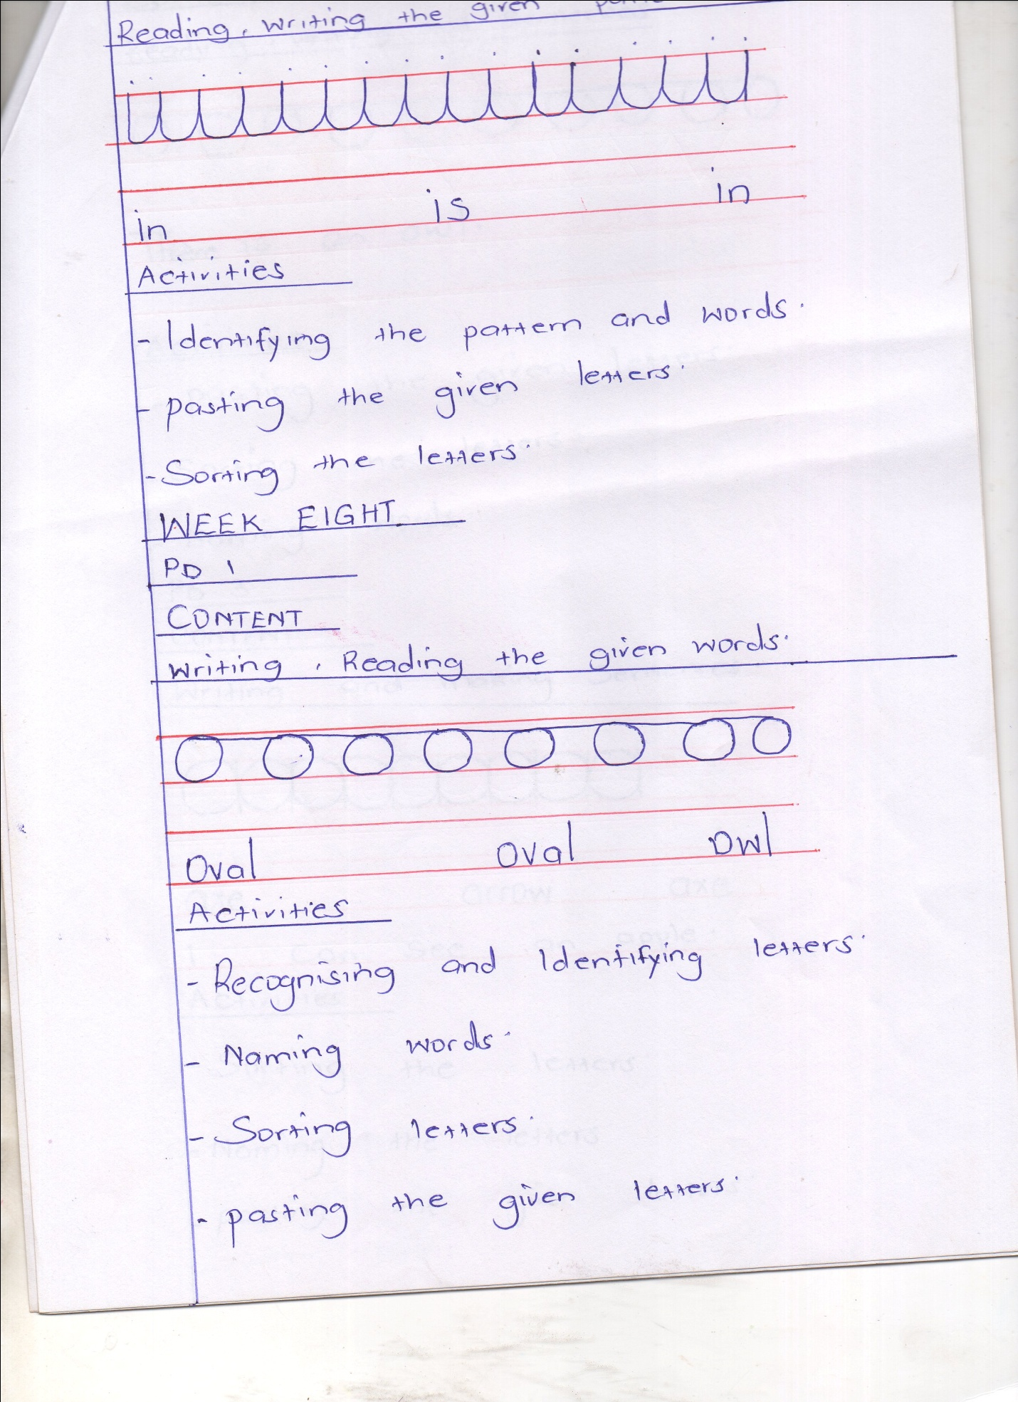Writing, reading the given words

Activities

* Recognizing and identifying letters
* Naming words
* Sorting letter
* Pasting the given letter

PD 2

CONTENT

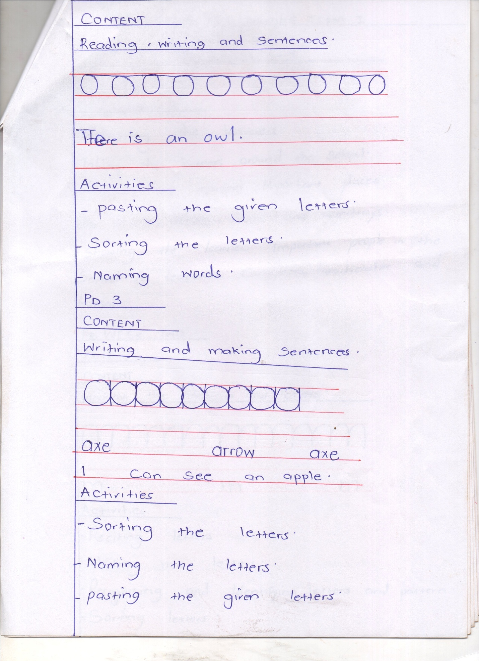Reading, writing and sentences

Activities

* Pasting the given letters
* Sorting the letters
* Naming words

PD 3

CONTENT

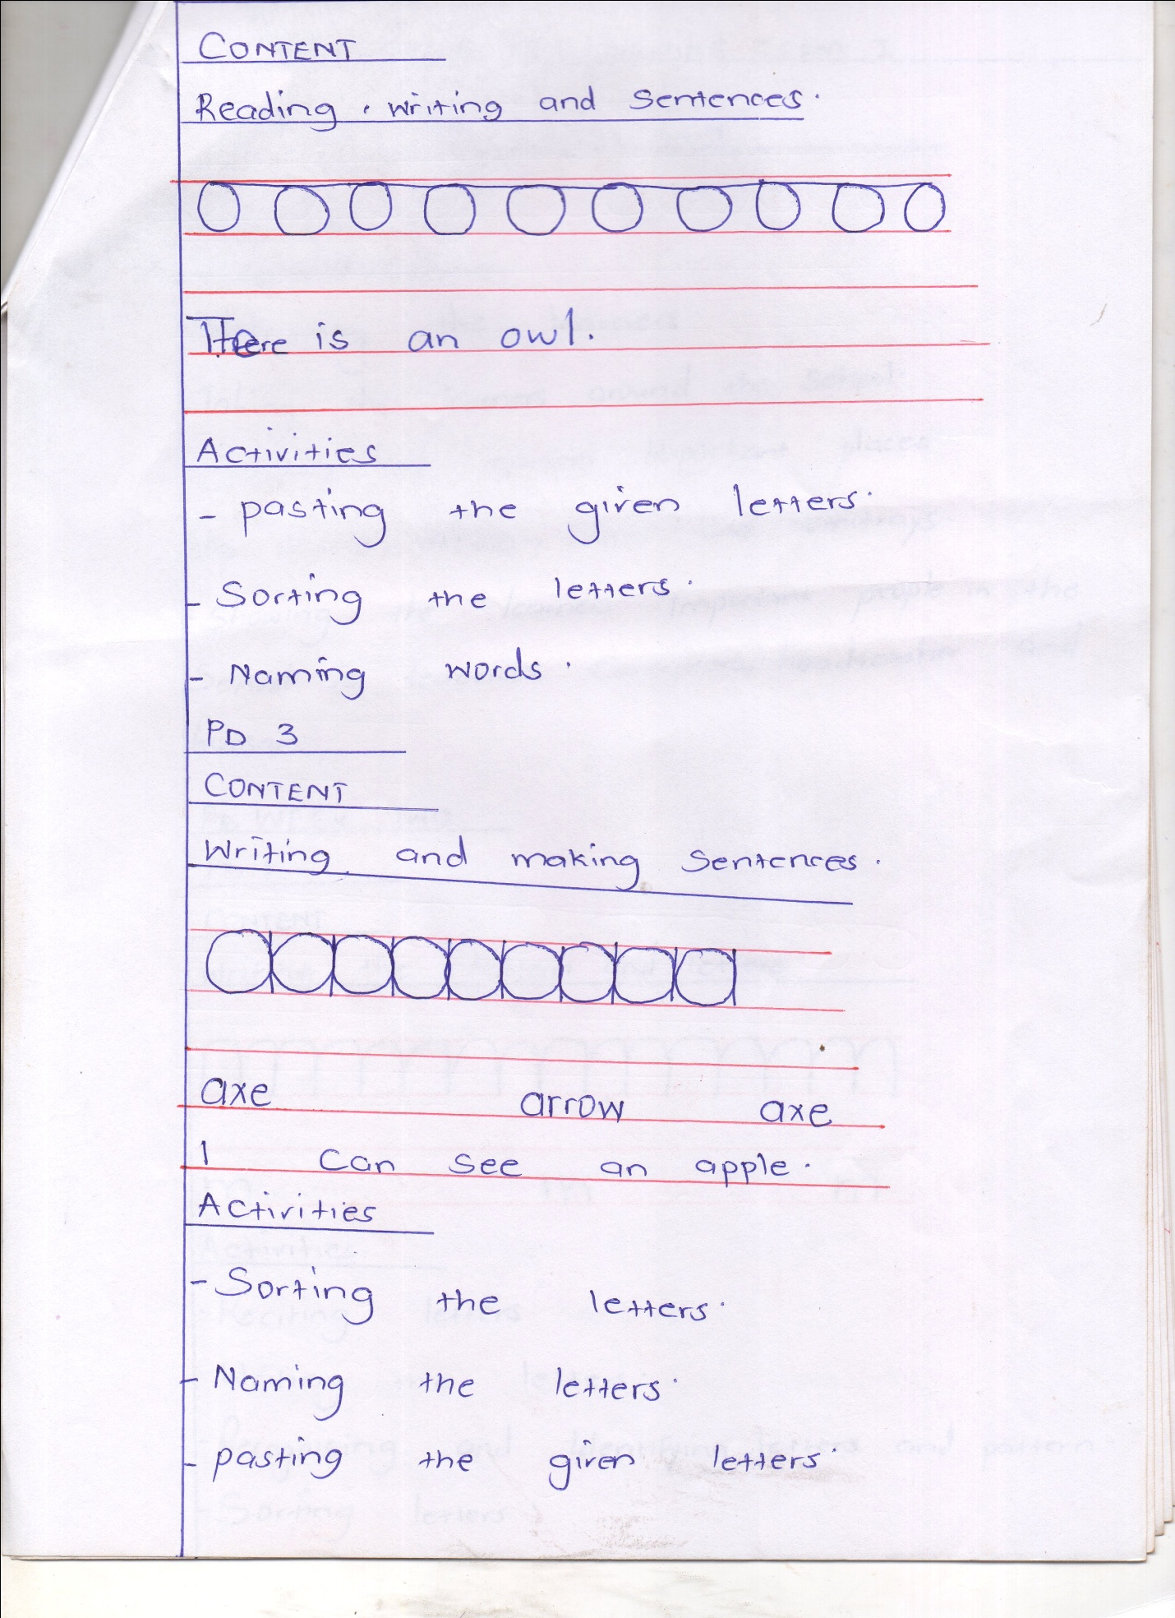Writing and making sentences

Activities

* Sorting the letters
* Naming the letters
* Pasting the given letters